A p r o j e c t

H E A LT H C A R E



**CSE 400:** Software Development Project **IV**

#### S U B M I T T E D B Y

|  |  |  |
| --- | --- | --- |
| **Name** | **ID** | **Intake** |
| Md.Abu essa | **19202103265** | 44 |
| Mir Billal Hossain | **19202103262** | 44 |
| Md.Mehedi Hasan | **19202103264** | 44 |
| Md.MorshadurRahman | **19202103151** | 44 |
| MD.Jubair Hossain | **19202103254** | 44 |
|  |  |  |

***S U P E R V I S E D B Y :***

**Md. Masudul Islam** *Assistant Professor, Department of CSE*

**DEPARTMENT OF COMPUTER SCIENCE AND ENGINEERING BANGLADESH UNIVERSITY OF BUSINESS AND TECHNOLOGY (BUBT)**

*09th, August, 2023*

# Abstract

[Due to revolution of Internet technology worldwide, the rapid use of mobile application

regarding various subjects increasing day by day. A good mobile application on Health Care is

user friendly to save the information of family members of current health condition. This

project “An Android Apps for Health Management System” is based on this concept of

development of a mobile application for health management. By using this application, it will

be very easy to maintain healthcare. Its functionality is very easy and anyone can use it to

manage family and personal health. Its functionality is designed according to the basic

demands of user. It provides much functionality among them. In Diet Chart management,

Vaccination management, Doctor Management, Medical History management and etc. The

intended project “Design and Development of an Android Application for Advanced Health

Management System” is targeted to facilitate users from home and abroad by giving

information using mobile.]

**Table of Contents**

#### Abstract

Chapter: 1 | **Introduction** .............................................. **Error! Bookmark not defined.**

* 1. Problem Specification/Statement
  2. Objectives
  3. Flow of the Project
  4. Organization Of Project Report

Chapter: 2 | **Background**

* 1. Existing System Analysis
  2. Supporting Literatures

Chapter: 3 | **System Analysis & Design**

* 1. Technology & Tools
  2. Model & Diagram
     1. Model (SDLC/Agile/Waterfall/OOM)
     2. Use Case Diagram
     3. Context Level Diagram

Chapter: 4 | **Implementation**

* 1. Interface Design/Front-End
  2. Back-End
  3. Modules

Chapter: 5 | **User Manual**

* 1. System Requirement
     1. Hardware Requirement
     2. Software Requirement
  2. User Interfaces
     1. Panel A
     2. Panel B

5.2.3. Login Credentials

Chapter: 6 | **Conclusion**

* 1. Conclusion
  2. Limitation
  3. Future Works

**Chapter 1 INTRODUCTION**

#### Problem Specification

[The problem that triggered the choice of this project is the need for a healthcare Android application. The current healthcare system faces challenges in providing accessible and convenient healthcare services to individuals. There is a growing demand for a mobile-based solution that can provide users with easy access to healthcare information, appointment scheduling, medication reminders, and other essential features.

The goal of this project is to develop an Android application that addresses these challenges by providing a user-friendly interface for accessing healthcare services. The application should allow users to search for doctors, book appointments, receive reminders for medication intake, track their health records, and access reliable healthcare information.

By developing a healthcare Android application, we aim to improve the overall healthcare experience for individuals, making it more convenient and accessible. This application will empower users to take control of their health and well-being, leading to better health outcomes and increased patient satisfaction.]

#### Objectives

[Its functionality is designed according to the basic demands of user. It provides much

functionality among them. There are Health article, Medicine Ordering System,

Doctor Management, Medical History management and etc. The project describes “Design and Development of an Android Application for Personal Health Management System” is an

enhanced instant usable application tool which user can use through the help of android base

mobile devices. By using this application every user can use it. It will be very easy to maintain family and personal healthcare and anyone.]

#### Scope

The scope of the healthcare project includes the following:

**Project Goals:** The primary goal of the project is to improve healthcare services

and outcomes

for patients. This can be achieved through various means such as implementing

new technologies, enhancing patient care processes, and improving access to

healthcare.

**Deliverables:** The project will deliver tangible outcomes that contribute to the improvement of healthcare services. This may include the development and implementation of electronic health record systems, telemedicine platforms, or healthcare mobile applications.

**Tasks**: The project will involve a range of tasks such as conducting needs

assessments, designing and developing healthcare solutions, testing and quality assurance, training healthcare professionals on new systems, and deploying the solutions in healthcare facilities.

**Costs**: The project budget will cover expenses related to software development,

hardware procurement, training, infrastructure upgrades, and ongoing maintenance

and support.

**Deadlines**: The project will have specific timelines for each phase and milestone,

ensuring that tasks are completed within the allocated timeframes. These deadlines

will be established based

on the complexity of the tasks and the overall project timeline.

Overall, the scope of the healthcare project aims to address specific healthcare

challenges, improve patient care, and enhance the efficiency and effectiveness of

healthcare delivery.

#### Organization Of Project Report

[Our chapter has total six chapter , first chapters is Introduction part and second chapter is Background part in third chapter of system analysis and design the third chapter includes various technology tools , Use case diagram , data flow diagram etc, and forth chapter is Implementation part in this part is coding part ,Back-End and Front-End included in this part and chapter five is User manual part this part is included requirement and user interface and the last chapter is Conclusion part in this part is included conclusion ,Limitation and Future Works ]

## Chapter 2

## BACKGROUND

#### Existing System Analysis

[**Functionality:** Many Android healthcare systems provide a wide range of services such

as appointment scheduling, health record management, medication reminders, patient

monitoring, telemedicine, etc. Some apps also have AI-driven features, such as

symptom checkers, diet and exercise suggestions, and more.

**Usability:** Healthcare applications on Android are usually designed with simplicity and

ease of use in mind. Many apps feature user-friendly interfaces, quick navigation, and

straightforward instructions. However, the usability can vary among different apps.

**Security and Privacy:** This is a critical concern for healthcare systems. Many Android

healthcare apps have robust security measures, including data encryption, secure user

authentication, and others. However, there have been instances where apps have had security flaws, leading to potential data breaches.

**Data Accuracy:** The accuracy of the data collected, stored, and analyzed by these apps is vital. While many apps take measures to ensure accuracy, others might have shortcomings that could lead to misinformation or misdiagnosis.

**Availability and Performance:** Healthcare apps need to be available 24/7, and they need to perform well under all conditions. Performance issues or downtimes can lead to user frustration and might even have more serious implications in critical health situations.]

#### Supporting Literatures

[In this healthcare Android project, several theoretical, mathematical, methodological, and technological knowledge, tools, and techniques have been applied to ensure its successful development. Below are some of the key areas that have been utilized:

**1)Theoretical Knowledge:**

a) Medical Concepts: Understanding various medical concepts, terminologies, and procedures is crucial for developing a healthcare application. This knowledge helps in designing features that align with real-world medical practices and ensure the app's accuracy and reliability.

b) User-Centered Design (UCD): Implementing UCD principles ensures that the Android app is intuitive, user-friendly, and caters to the needs of both healthcare professionals and patients. It involves conducting user research, creating user personas, and incorporating user feedback throughout the development process.

**2)Mathematical Knowledge:**

Data Analysis: Mathematical tools such as statistical analysis are employed to process and interpret medical data. This analysis can provide valuable insights into patient trends, disease patterns, and treatment outcomes, helping healthcare providers make informed decisions.

**3)Methodological Knowledge:**

a) Agile Development: Agile methodologies like Scrum or Kanban are commonly adopted in software development projects. These iterative approaches promote flexibility and continuous improvement, making it easier to adapt to changing requirements and deliver a high-quality product efficiently.

b) User Testing: Conducting user testing at different stages of the project allows for identifying and rectifying usability issues early on. User feedback helps in refining the app's design and functionality, ensuring a better user experience.

**4)Tools & Technological Knowledge:**

a) Android Development: Utilizing Android Studio and the Android SDK (Software Development Kit) facilitates the creation of a feature-rich, native Android app that can seamlessly run on a wide range of devices.

b) Cloud Computing: Integrating cloud-based solutions enables efficient data storage, backup, and access. Additionally, it enables the app to scale and handle a large volume of data and users effectively.

c) Data Security: Implementing robust encryption techniques and security protocols ensures

the protection of sensitive medical data and compliance with healthcare regulations.]

## Chapter 3

**SYSTEM ANALYSIS & DESIGN**

#### Technology & Tools

[Several tools and techniques can be used to design, develop, and maintain an Android healthcare

**Software configuration:**

Android Studio: This is the official integrated development environment (IDE) for Android application development. It provides a powerful code editor, debugging tools, and a visual layout editor.

Operating system: Windows 7, 8,10

Language: java Runtime Environment, SQLite Database)

**Hardware Configuration:**

Processor: Pentium(R) Dual-core CPU to corei-7

SSD: minimum 120GB

RAM : 8 GB or more.]

#### Model & Diagram

#### Model(SDLC)

#### 

#### Use Case Diagram

#### 

#### Context Level Diagram

#### 

## Chapter 4

**IMPLEMENTATION**

#### Interface/Front-End Design

[Discuss briefly designed the project interfaces, outlook, front-end part.]

The design work of each section is almost the same so we are discussing the Login section.First we create a empty project after that we design a login page when we design a login page we need a text box for something write, then we need a username and password field .All field available between palette field for example TextView,Button,ImageView etc. We can text size edit with coding and without coding .If we want to change different size then we can use paddingLeft, paddingRight,paddingTop,paddingBottom. We can see the design part of the Login page below.

#### Interface/Back-End Design

[Discuss briefly developed functionalities, back-end part, CRUD in your project.]

Back-end main work is different data save in database . So in this project all data save in database for example Login section two part one part is username and another part is password

So ,both part is important for login .Username and password both data save in database .

First we create onCreate function and create a string object .

example is :

String qry1 = "create table users(username text,email text,password text)";

sqLiteDatabase.execSQL(qry1);

When we need to login we need username and password and if we have registered username and password in database ,if they don’t match then login won’t happen.

* 1. **Output**

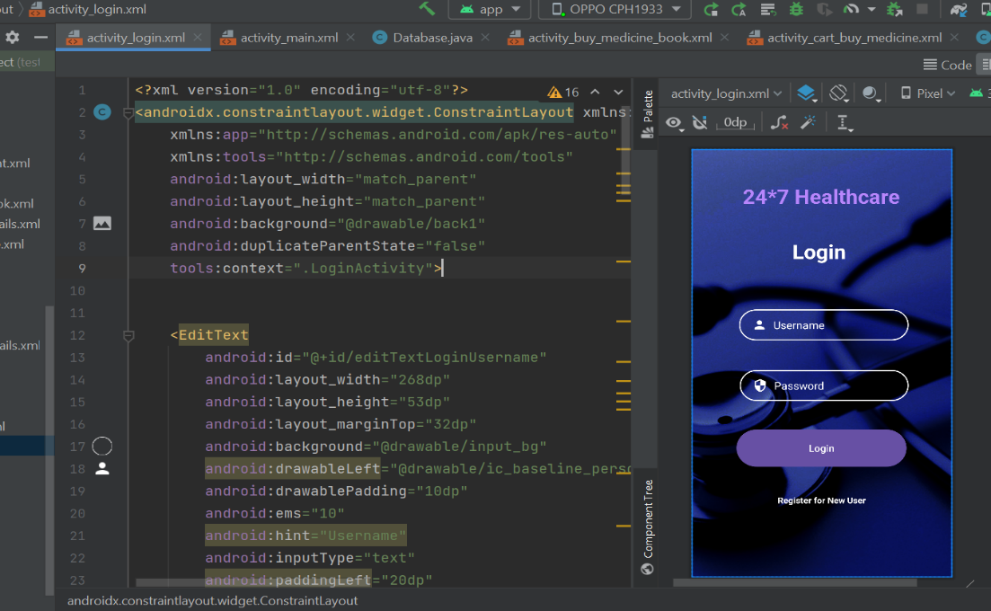

## Chapter 5

**USER MANUAL**

#### System Requirement

* + 1. **Hardware Requirement**

[Write the minimum recommended Hardware configuration to setup and run your project successfully.

1. Android Device
2. Camera
3. Microphone
4. Speakers
5. Storage
6. Connectivity
7. GPS
8. Battery]

#### Software Requirement

[Write the minimum recommended Software configuration to setup and run your project successfully.

1. Operating System
2. Database
3. Data Encryption Software
4. Development Tools
5. Accessibility Software
6. User Interface Design Tools]

#### User Interfaces

#### Panel A 5.2.2 Panel B

#### 

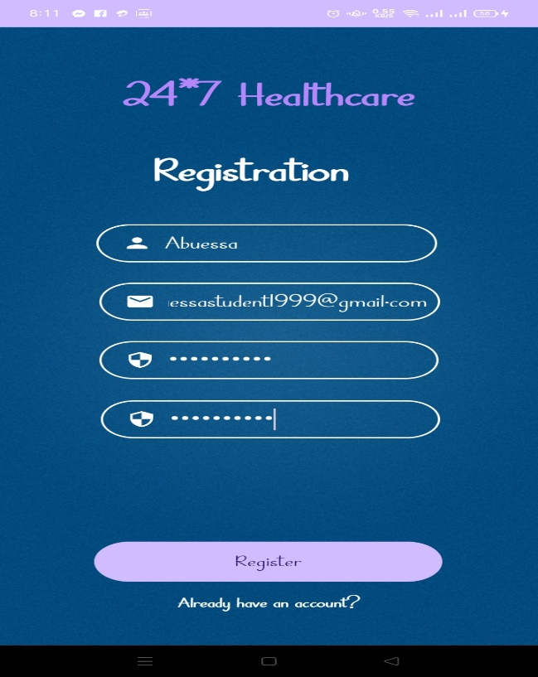

Login page

Registration page

#### 5.2.3 Panel C 5.2.4 Panel D

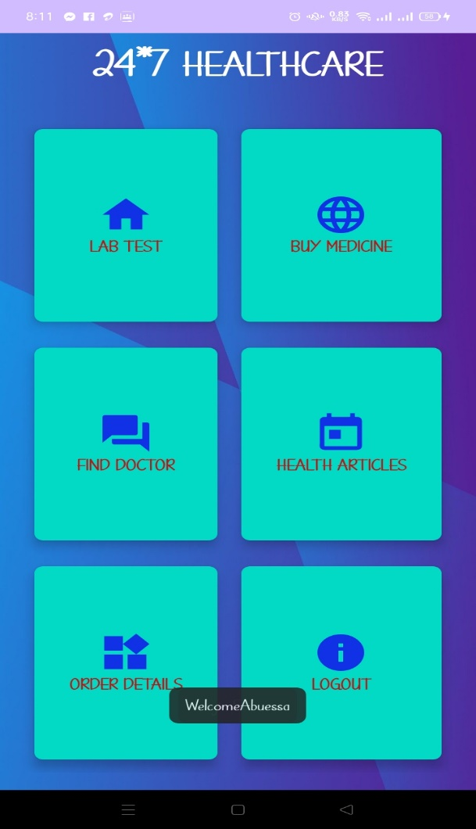

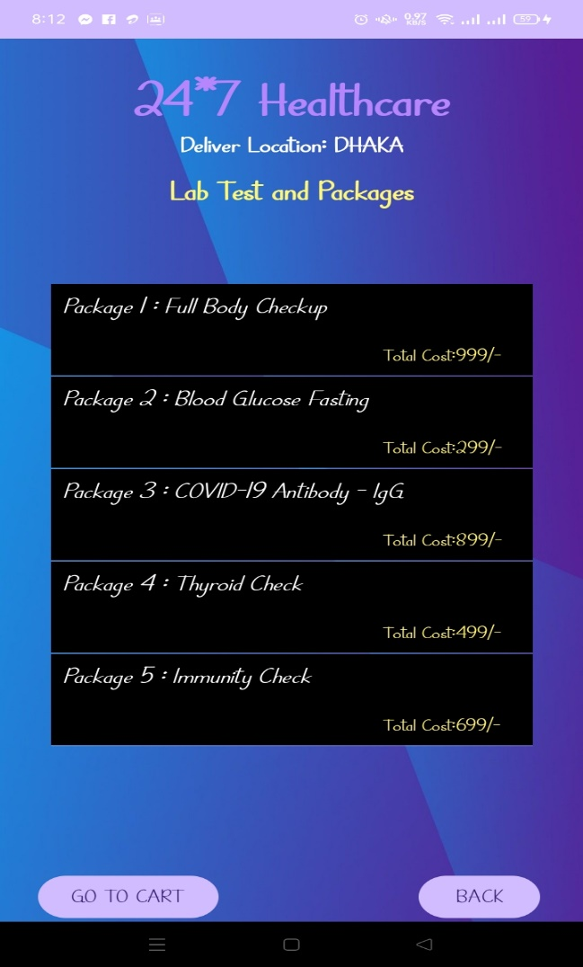

Lab Test and package page

Home page

#### 5.2.5 Panel E 5.2.6 Panel F

#### 

#### 

Full body checkup page

Buy Medicine page

#### 5.2.7 Panel G 5.2.8 Panel H

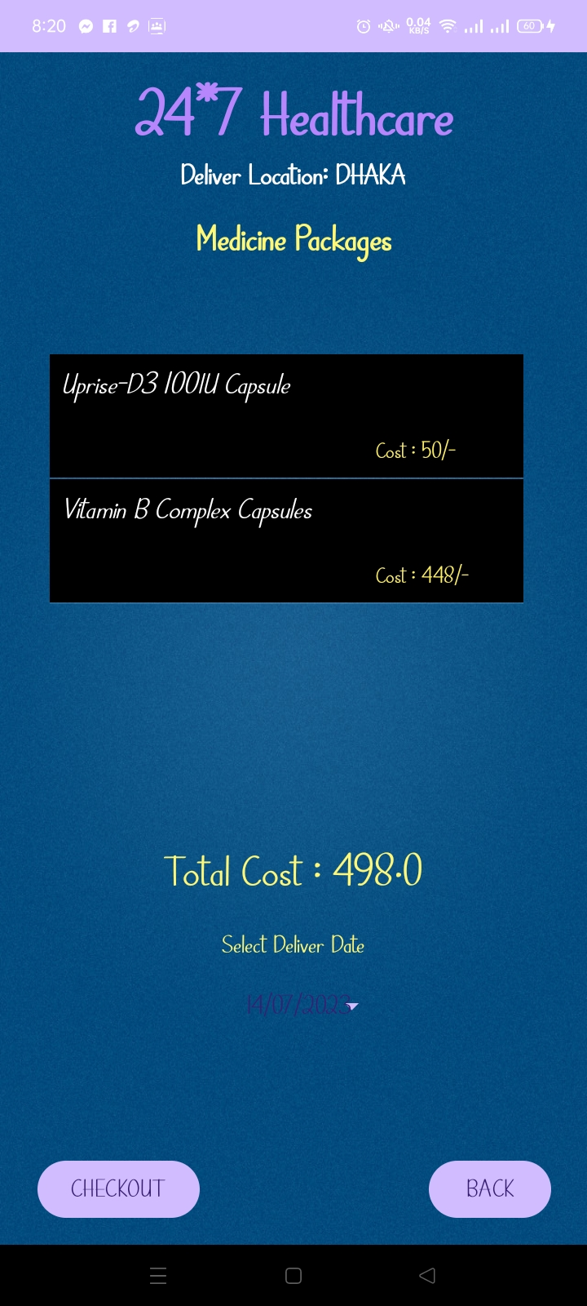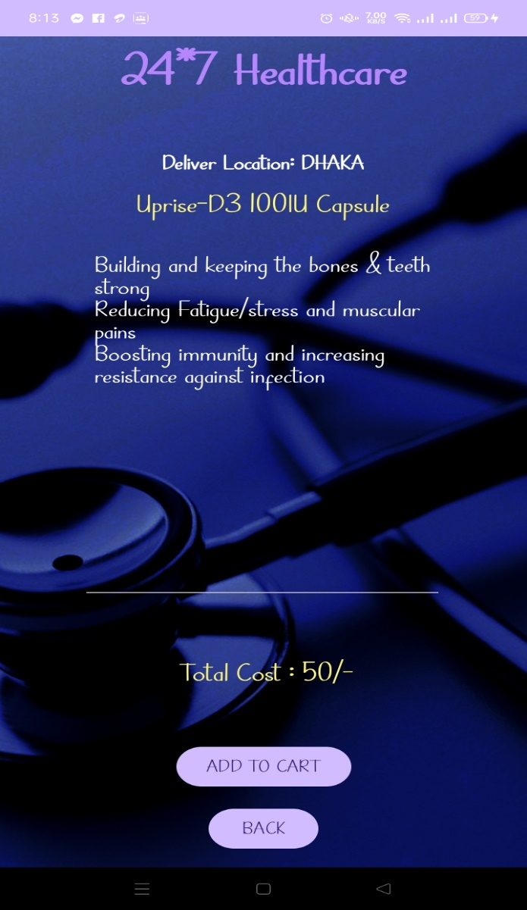

Medicine package page

Medicine details page

#### 5.2.9 Panel I 5.2.10 Panel J

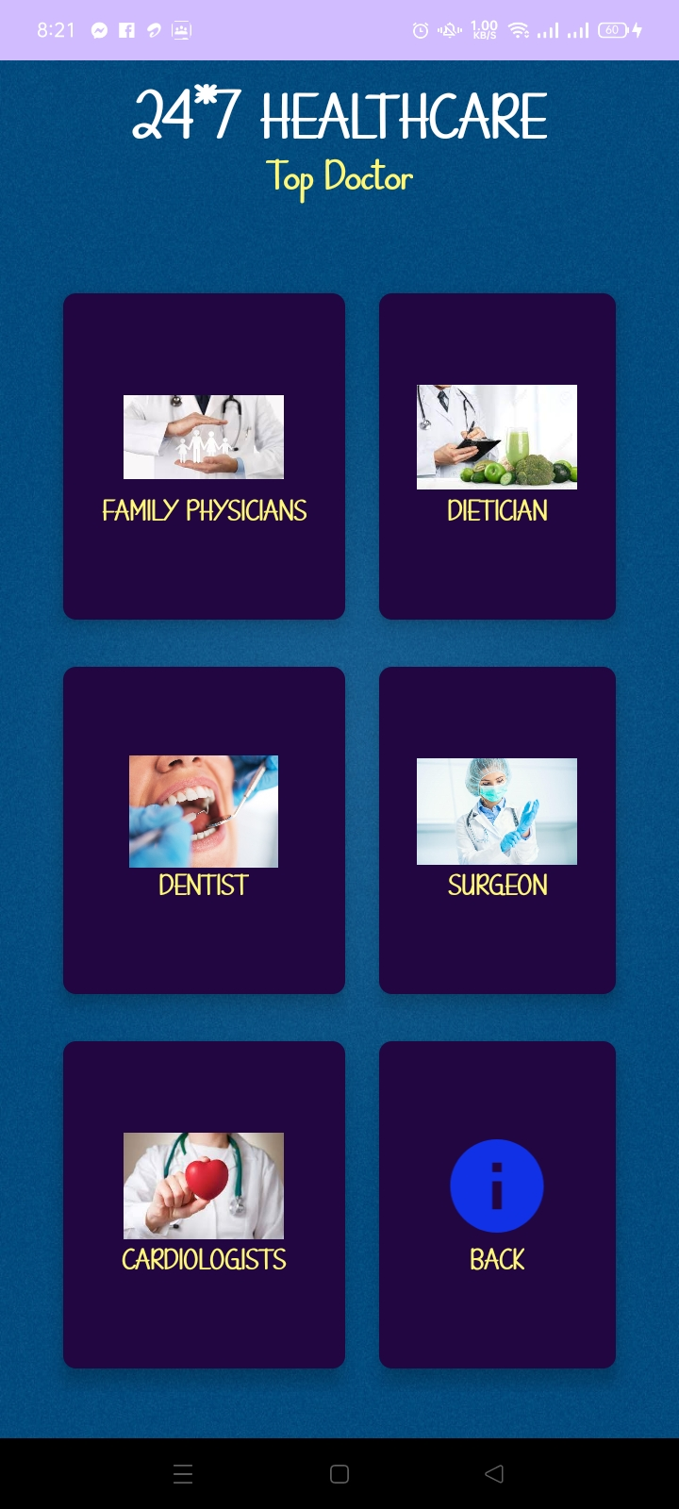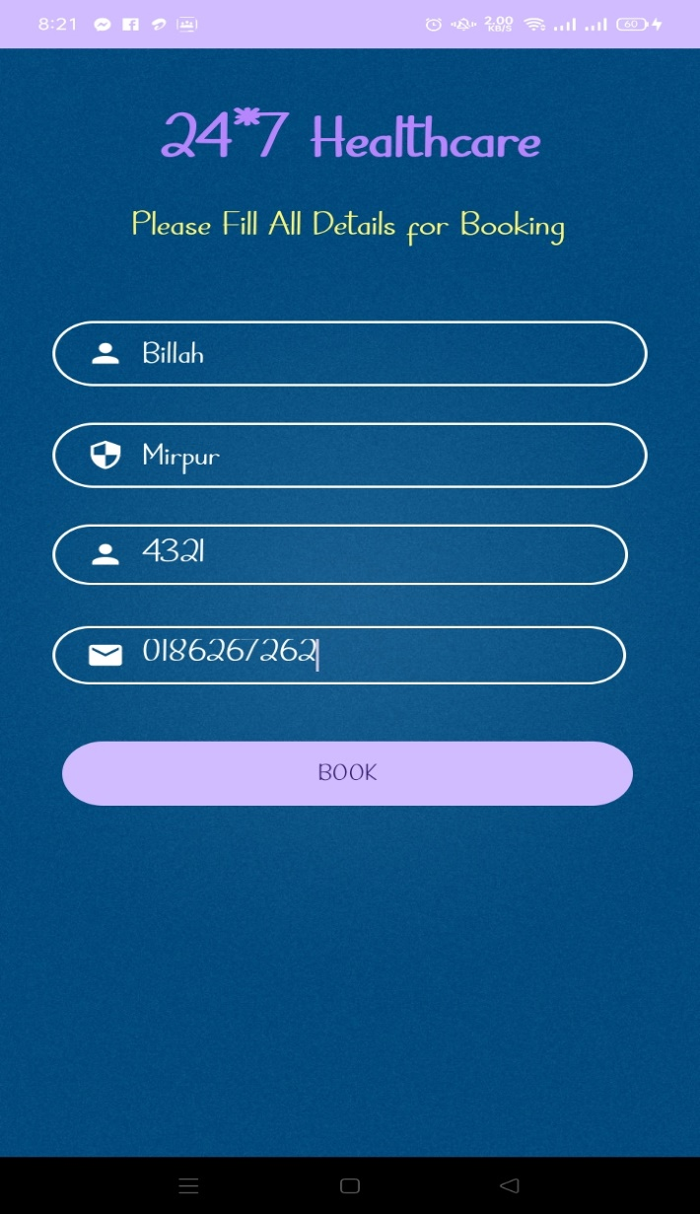

Medicine Booking page

Find doctor page

#### 5.2.11 Panel K 5.2.12 Panel L

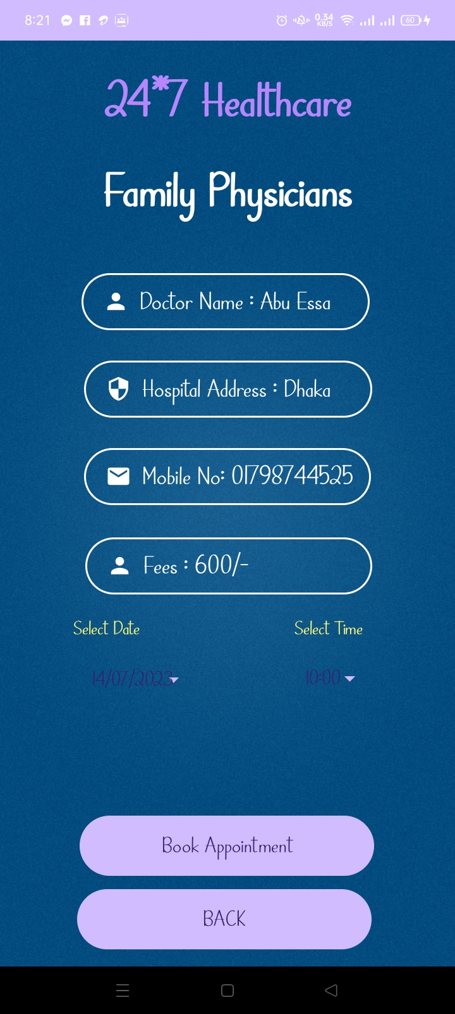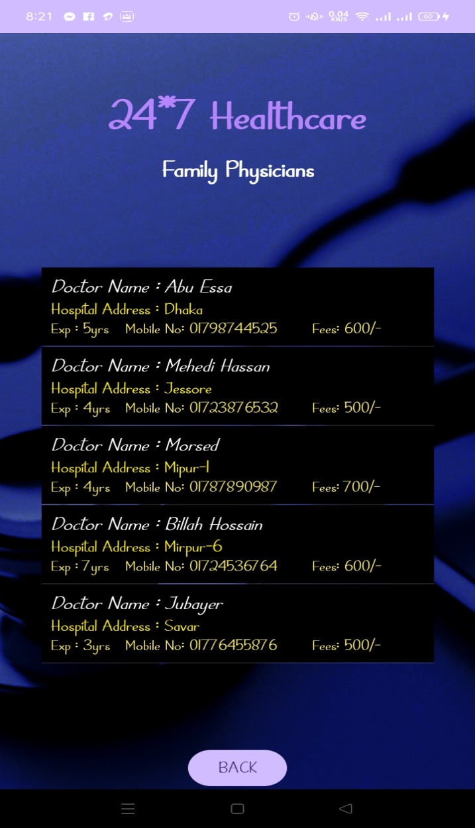

Doctor Booking page

Doctor details page

#### 5.2.13 Panel M 5.2.14 Panel N

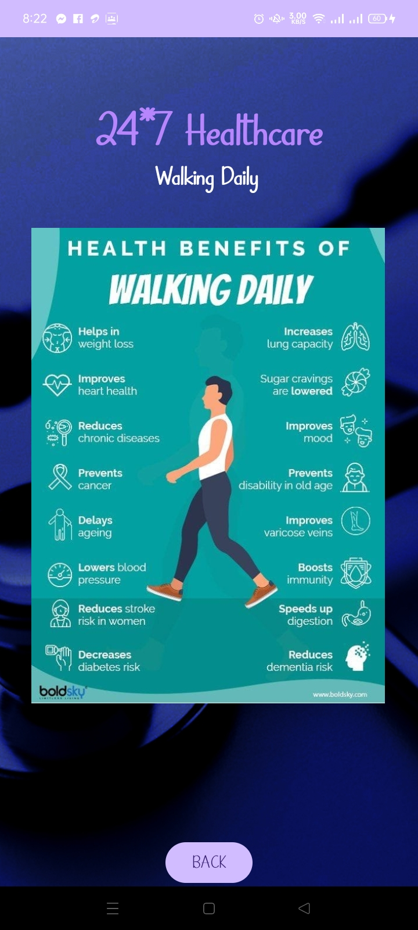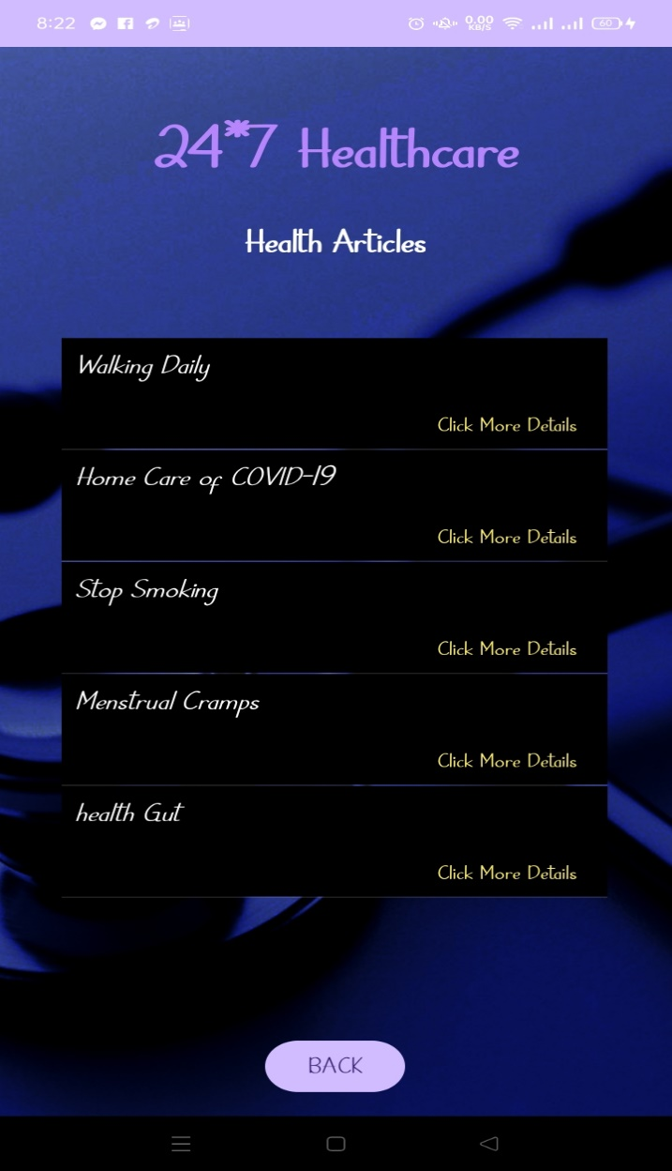

Walking page

HealthArticles page

#### 5.2.15 Panel O

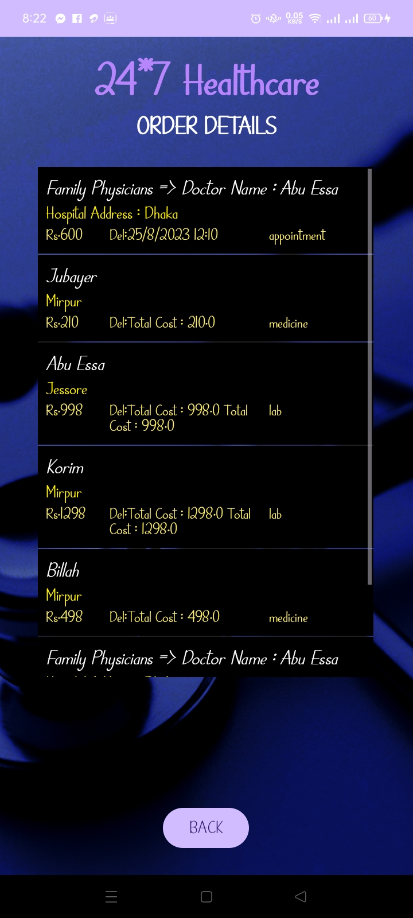

Order Details page

## Chapter 6

**CONCLUSION**

#### Conclusion

[In conclusion, developing an Android healthcare project requires a range of tools and technologies. These tools and technologies include Android Studio, Java etc. These tools and technologies make the development process more efficient, help to optimize performance, and ensure the reliability and security of the application. Developers can use these tools and technologies to build healthcare applications that provide users with access to medical information ,find doctors and the user see all order details etc. The ultimate goal of an Android healthcare project is to create a user-friendly and reliable platform that supports better health outcomes for users.]

#### Limitations

[1. Data Security and Privacy

2.Accuracy of Collected Data

3.Internet Dependency

4. Digital Literacy

5.Maintenance and Update

6.Accessibility]

#### Future Work

[There are few thing that we are going to add to our website are given below:

1. Packages added in user Registration

2. Developed Gigs Posting System

3. Upgrade the Post page Design

4. Create the add any File/Gallery Section

5. Search Engine Optimization

6. Upgrade User Interface